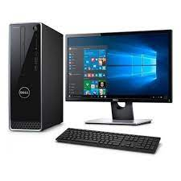

DELL 3670

* Intel Core I5-7400 Quad-Core
* Capacity 16GB,12GB
* Windows 10 Home
* Memory 2400 MHz DDR4

**Rs.46,020**